20th July 2025
Call to worship
Come worship the God made visible in Jesus.
Come worship the one,
who holds all things together.
Come worship the one
who is beginning and end.
A gathering prayer
Lord, as we gather here today,
open our eyes,
so we can truly see you.
Open our ears,
so we can truly hear you.
Calm our busy hands,
so we don’t miss a thing.
Amen.
A prayer of approach
Living God, give us eyes to see you
in creation, in strangers, in another;
give us ears to hear you in words, in music, in silence;
give us voices to proclaim you in
our homes, churches and communities;
and give us lives to celebrate, serve and revere you
in all places, at all times and among all people.
Amen.
A prayer of adoration
God of all the world, thank you for showing us
your creative love in all that surrounds us.
Lord Jesus, thank you for showing us the Father’s love
in your life, death and resurrection.
Living Spirit, thank you for showing us that all things are possible
when you breathe on us, empower us and bless us.
Holy Trinity, thank you for the ways you show us your love
and draw us into your kingdom.
Amen.
A prayer of confession and an Assurance of forgiveness
A prayer of confession
Forgive us, compassionate God, when we fail to see you:
in the faces of strangers; in the tears of the desperate;
in the anxiety of the afraid; in the silence of the broken;
in the fragility of creation; in one another or in ourselves.
Forgive us and help us to encounter you afresh.
Amen.

Assurance of forgiveness
God of wonder,
though we don’t always see you, you always see us.
Although our eyes aren’t always open
to the ways of your kingdom, it is always open to us.
Although we don’t always recognise you
in our daily encounters, you are always there.
Thank you for meeting us where we are,
for your grace and forgiveness,
and your life-giving Spirit, which fills us day by day.
Amen.
A prayer of praise and thanksgiving
We praise you, God of encounter and promise,
for those kingdom moments in our lives that
have been turning points; those encounters that
have given us fresh eyes, new insights, warmed hearts;
those people whose eyes have been so fixed on you that
they have inspired us in our faith and in our daily lives.
We praise and thank you for all the ways you meet us
in one another, and most of all we praise you for your Son,
Jesus Christ, our Lord and Saviour.
Amen.
In one of Paul’s richest theological reflections on the coming of Jesus, he talks about the crucified Christ as the invisible God made visible. True authority and power are not found in the pomp and might of Caesar, but in the humility and suffering of Jesus.
Extra ideas can be found by using the Jump to this week's menu on the right.

Prepare
Read Bible notes on Colossians 1:15-28
This passage comes early on in Paul’s letters to Colossians, confirming who God is, how we can see the invisible God made visible through Jesus, God’s Son. This is important in establishing Jesus as divine and not merely another prophet.
Grappling with the invisible and mysterious can be a difficult part of faith. However, exploring this together can also be a powerful way of thinking about a relationship with God that is personal and can be expressed and experienced in different ways. It’s also a good opportunity to explore the tangible actions of Jesus on the cross, which some young people may connect more easily with.
Gather
How do you see God? E
- Explain that in today’s session we explore who God is, and how we can understand God (invisible) through Jesus (who was visible), who was God come to earth. Everyone is likely to have a different image of God in mind, whether this is vague or very specific.
- On the Camino ‘Someone/something there: life force’
- .

First impressions

Questions
- Have you used digital photography to help you see something more clearly?
- What helps you to see and know God?
- Where in nature do you see God?

The image of what we cannot see
Look at what is not visible
You will need: images: X-ray pictures, Ultrasound scans, UV light, Microscope pictures.
- Show the images of x-ray pictures, ultrasound scans, objects shown up under ultra violet light and a photo taken through a microscope. Discuss what they all have in common.
- Talk together about how these are all ways of helping people to see things they can’t normally see.
- Finally, show the image of Jesus and explore together how Jesus is a way that people could see God. Discuss: How does seeing something that you can’t normally see change the way you think about it?
Blurred quiz Look at unclear things becoming clearer
You will need: ability to show images on a screen, or images printed out to look at
- Display a range of famous celebrities with blurred faces as a quiz, either on screen or sheets, making the point that things are not always clear.
- See how many the young people can identify, discussing as you do how being familiar with the person already can help identify unclear images.
- Talk about how this relates to God who we can’t see clearly, but being familiar with God through Jesus can help to make what is unclear, clearer.

Visualising God
Look at sheet of paper. What helps you to ‘see’ God?

How other people ‘see’ God
You will need: willing volunteers to share their stories.
- Invite one or two people of different ages, backgrounds and experiences to come and share a few minutes about how they see God at work in their day-to-day lives.
- Ask the volunteers to talk about how they visualise God, to help the children understand that everybody has a different relationship with God and a different way of understanding/ visualising God.
- Invite the children to ask questions (or you might pre-prepare these).

God is…
You will need: cards with the following words on and objects (in brackets) to accompany them ‘we meet God in Jesus’ (cross), ‘we hear God in the Bible’ (Bible), ‘we see God in creation’ (plant/flower), ‘we feel God when we hug a person we love’ (play people), ‘we sense God when we are still and quiet’ (cushion to sit on).
- Show the children the cards and accompanying objects and talk about each one. Then place each one in a different part of the room and ask them to move around and think about which one helps them to feel close to God.

A gathering prayer for children
Heavenly Father,
it’s great to be here.
Today we can see… (name everyone in the group)
Help us to see you in them and in your Son, Jesus.
Amen.
Share the Word
Colossians 1
GOAT

Who is Jesus? W E
Understanding Jesus to understand God
You will need: large piece of paper, pens, Bibles.
- Ask someone to draw a large person shape on the piece of paper.
- Invite a discussion about the knowledge the young people have about Jesus – they can refer to Bibles if they wish. This should focus on what Jesus showed by his words and actions, how they would describe Jesus and, ultimately, what this might show us about a God who is unseen.
- Encourage the young people to fill the person shape with words, phrases, images as they describe Jesus.
- To finish, explore any further questions the young people still have: what do they still struggle to understand or believe despite what they know about Jesus?

Guided meditation E S
Create an atmosphere to experience God’s presence
You will need: an image or piece of artwork to focus on (suggestion – Prince of Peace by Akiane Kramarik story of the painting: https://www.youtube.com/watch?v=zGgjaYLkh2E
Prince of Peace

Kramarik has said Prince of Peace is her "favorite portrait" and one of her most memorable paintings.^{[11][12]} At age eight she had long been seeking the right face to help her paint an image from her dreams and visions when a family friend brought to her a carpenter as a possible subject. The man's face closely resembled what Kramarik remembered as the face of Jesus. She completed the portrait in 40 hours of intensive work. Not long after, it was shipped to her agent for exhibition, who then stole it and sold it without permission. For sixteen years the original painting was held locked in a bank vault, with the then-owner unwilling either to show or to sell it.^{[12][13]} In December 2019, Prince of Peace was recovered by the artist's family and sold to a private collector for $850,000.[
https://revwords.com/encounter-god-akiane-kramarik/
Akiane Kramarik’s atheist parents were surprised when their three-year-old began to describe dreams and visions from God. This inexplicable direction in their daughter’s life, combined with a remarkable talent in art and poetry, inspired her family to re-examine their own lives.
An Encounter With God
“My life began in an unusual way,” says Akiane, 17, who spent her early years in rural Illinois. By unusual, she refers to her underwater birth in “a shack” on the edge of a cornfield. “Our family had no money, no friends, no relatives, no television or radio. Our life was quite simple — long walks in nature, open conversations, and hands on explorations of knowledge,” she says.
Her mother, Forelli, is a Lithuanian immigrant educator. Akiane’s father, Mark, is a chef from Chicago with a Catholic background. In her early family life, there was no prayer, no discussions of God, and no visits to church.
Yet in the atheistic environment her parents created – free from media influences or even outside babysitters – Akiane suddenly began to talk about God.
The Face of Jesus
She spoke of colorful dreams and visions about heaven, Jesus, and God’s amazing love. Her stunned parents realized her intense focus on God could not have been inspired by anything in the world they created for her. Indeed, Akiane seemed to be having supernatural encounters with the living God.
“Most of my spiritual experiences I kept secret, so as not to overwhelm my parents,” she says. “When I was four years old, suddenly I started experiencing vivid impressions about different dimensions and a great desire to express them through art,” she says.
At eight-years-old, Akiane decided she wanted to paint the face of Jesus, based on the visions she received.
A Discovery of God
Akiane’s painting of Jesus was a painstaking effort. “The ‘Prince of Peace’ took me 40 hours to paint and another 20 hours of working with model sketching,” Akiane says. She deftly works with light and shadows to create powerful impressions. “The light side of his face represents the truth, the dark side represents suffering,” she notes.
Akiane’s discovery of God seems remarkably personal. “Since nobody told me who God was, I found God myself. He’s been there for me through the years. I don’t belong to any denomination or religion. I belong to God.”
To eliminate any confusion, however, Jesus is first in her mind. “He is the only way to God — the only way to heaven and joy,” she states. “My personal views on Jesus have only matured and deepened since age 4. As I grow I see how vast and unlimited His love is.”
Jesus’ Glory
“Jesus remains my highest authority, love, and God. I pray every day that people will one day follow Jesus, His teachings and feel His love.”
“I alone know how important Jesus is for me. Instead of writing it is best for me to express (this) through my personal connection — art. I portray Jesus how I see him, as human and as divine.
“My art is only a representation of what I see — Jesus’ glory is beyond any description!”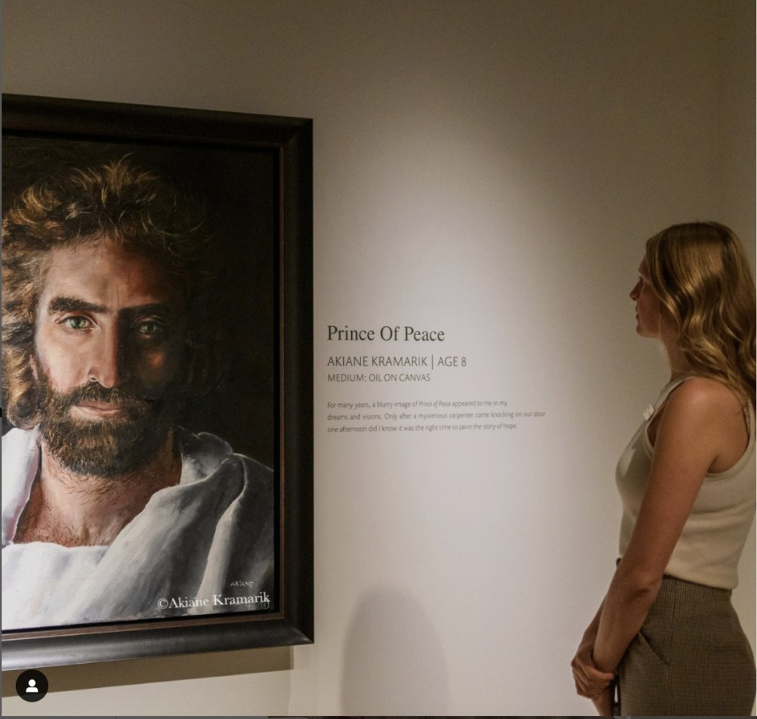
Akiane painted the “Prince of Peace” at the age of eight. She is now 30 years old. The painting took her forty hours to complete, and the finished work was almost as tall as the artist herself.

- Have a copy of today’s passage available for them to reflect on.
- Invite them to focus on the image of Jesus, the artist’s vision of what Jesus may have looked like. Encourage them to call to mind their own impressions of Jesus as well as their questions from Who is Jesus? and to think about how knowing, picturing and exploring who Jesus is can help them to understand and ‘see’ God.
- . Finish by talking about how everyone sees God differently and we can all talk to God and get to know God through prayer. Allow a few moments of quiet prayer for children to feel close to God through the images they’ve made, and as they pray.

A sending out prayer for children
Invisible God,
help us to use our hands to do your work. (wave hands)
Help us to use our feet to visit those in need. (stamp feet)
Help us to use our eyes to see how we can help. (blink eyes)
Help us to use our ears to listen to others. (point to your ears)
Help us to show your love to everyone we meet. Amen.

Prayers of intercession
At the beginning and at the end of the intercessions you might like to sing together:
Be still, be still;
know that I am God.
Written by Eric Wyse © 2006 Petaluma Music performed by The London Fox Taize Choir
Or
Be still and know that I am God (Voices Together 37)

Loving God
we come to place into your hands
ourselves, our lives and our concerns for the world in which we live.
As our attention is divided and our world becomes increasingly rushed and noisy
and we feel the constant pressure to be doing
more and more with fewer and fewer resources,
we pray that we would find our still centre in you
and that our actions would be rooted and grounded in your abundance.
Come close to us O God
All: Hear our prayer.

As world leaders struggle to make and keep the peace
and the suffering caused by wars seems unending,
we pray that you would keep alive our hope in a better future
for all the peoples of the earth,
remembering particularly the efforts to build a just and lasting peace
in the Middle East and between Russia and Ukraine.
Come close to us O God
All: Hear our prayer.

As social media scatters our attention and fragments society
and shouting replaces conversation, listening and debate,
we pray that we would be disciplined in our use of technology
and that we would pay attention to others
and use our words to build up other people.
Come close to us O God
All: Hear our prayer.

As four areas of England move into drought following extreme heat
and wildlife and crops are under threat,
we pray for more careful stewardship of Earth’s precious water resources
and for accountability where water is polluted by carelessness
or choices driven by greed.
Come close to us O God
All: Hear our prayer.

As our rights to peaceful protest become increasingly limited
and challenging the status quo comes at great cost,
we pray for wisdom to discern the actions to which you are calling us
and courage as we respond to issues that threaten life and stability on this planet.
Come close to us O God
All: Hear our prayer.

As people struggle with life’s challenges or are overwhelmed by trouble
and some we know are ill or in hospital
we pray for peace in body, mind and soul for all who are suffering and strength for those who care for them.
(Today we remember in particular… )
Come close to us O God
All: Hear our prayer.

As so many people are rootless and lonely in our communities
and young and old seek a place to belong and to be heard
we pray that our churches would be places of hospitality,
where bread is broken and shared
and friend and stranger find a welcome home.
Come close to us O God
All: Hear our prayer.
A prayer for all ages together
Lord Jesus, you help us to see God.
This week, open our eyes to seeing you
in the world around us
and the people we meet.
Amen.
A sending out prayer
Lord, life is busy.
Help us this week to take some time
to sit at your feet
and truly see and hear from you.
Be in our decision-making and in our thoughts.
Amen.

