Sermon
Luke 6.37-42
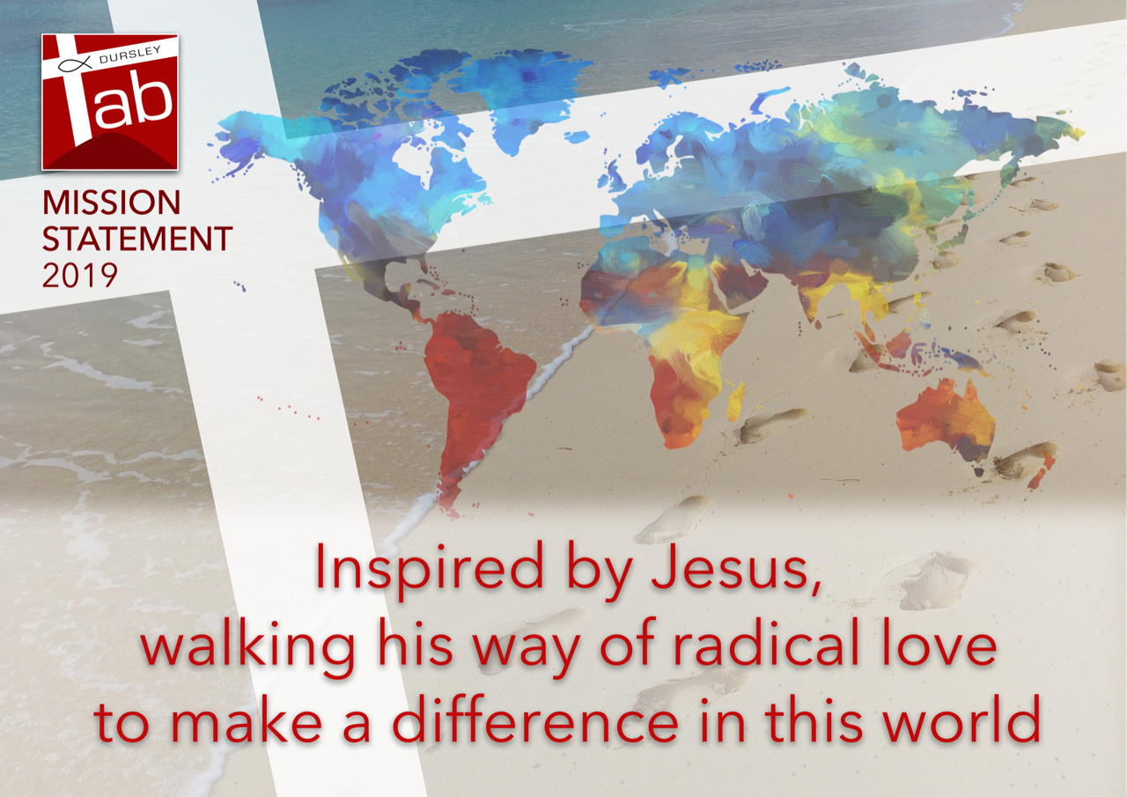
At the start of his best-selling book ‘What’s so Amazing about Grace?’ Christian author Philip Yancy tells a true story about a conversation a friend of his had with a homeless prostitute who confessed about the depths to which she had stooped to feed her drugs habit. As she spilled out terrible details, he asked her if she had ever considered going to a church for help to which she replied: “Church!? Why would I ever go there, I already feel terrible about myself. They’d just make me feel worse.”
As uncomfortable as it is I think all of us, hand on hearts can recognise where she is coming from. Given the unequivocal ‘Do not judge’ we have just heard from Jesus in Luke’s Gospel, given the emphasis on God’s forgiveness and faithfulness throughout the Bible, how is it that the Church has largely become known for what it is against rather than what it is for? People all too often, and with good reason, expect the Church and Christians to be judgemental.
In this third of our Lent sermons on Walking the Way of Jesus we are looking at this passage from Luke which comes towards the end of the sermon on the Mount, where Jesus tells his followers that a fundamentally different new world is breaking into this one and he sets out radically different principles along which they should live their lives.
Personally, I am not sure whether it would have been more exhilarating or disturbing to hear Jesus speak on that hillside, he was no modern-day politician sugaring the pill that’s for sure. So far he has healed people, gathered his 12, eaten with tax collectors, preached locally in a launch of his ministry. Now he is hitting people between the eyes with his manifesto. Not many modern leaders, if any, would win hearts and minds by declaring: woe to you who are full now for you will be hungry, love your enemies - as we heard last week- , do not judge and you will not be judged. The prize is priceless – to be in step with the will of God our creator – but even so, it must have been tempting to pick out the palatable parts of the Sermon on the Mount and skip the ones that required huge change and commitment. That temptation is still real today.
We have a new mission statement as you know and can see on the slide and a few years ago now one of America’s most influential megachurches Willow Creek Community Church in Chicago conducted a study among its members to see how they were performing against their mission to ‘raise up fully devoted followers of Christ’. This is a church with 24,000 members, undisputedly successful in drawing people to God. But the survey results were painful to read. It showed that while they were incredible at making believers they had a long way to go in forming followers or disciples. People can believe in Jesus, but still not follow him, not live the lifestyle set out for us on that hillside and throughout the Gospels.
Last week a group from our church heard a challenging illustration of a church being made up more of believers than followers when they travelled to Oxford for a session on how to become an autism friendly church. It was a moving seminar including personal testimony about the isolation and hurt experienced by families with a child with additional needs. Simon shared how one person said their worst experience as a Christian family was at church. At church. The dad said: ‘You expect it out in the world but you come to church looking for hope and it’s the hardest thing when that hope is dashed.’

Judgement and condemnation are everywhere in our culture. Young people bombarded with edited images on social media chase the elusive perfect appearance, many suffering a crisis of self-belief because, not surprisingly, they can’t ever match up.
TV viewing for the past 15 years has been dominated by talent shows with judges. Can the competitors sing, dance, skate well enough to make the grade? Can they cut the mustard? Watching people be judged has long been a spectator sport, but in recent years insulting and condemning contestants seems to have become fair game. We can vote from apps on our mobile phones and become judges ourselves, join in the big game of win or lose. And there are many, many more losers than winners. The deal is this – as long as you entertain me you can stay, the moment you fail to shape up, the contract is broken and it’s ‘time to say goodbye’.
A ‘contract’ response to relationships will always be self-centered – what’s in it for me? We might hungrily accept love to fill our own emptiness, perhaps looking for partners or friends to make us feel better and then become frustrated or resentful when they no longer meet our needs.
But God doesn’t make a contract with us, he blows that transactional thinking right out of the water with the startling, revolutionary covenant with us, with all people, that came through the life and death of Jesus.
God says to us I will love you with an everlasting love – even when you run away from me, reject me, betray me, nothing can separate me from you.
Our challenge then is to love whom God loves how God loves them. To receive God’s love and pass it on. Throughout the Gospels we see people who wanted Jesus to stay longer with them so they could learn more, soak up his company and teaching. We heard a couple of weeks ago Luke’s record of the transfiguration and how Peter wanted to build shelters where Moses, Elijah and Jesus could stay. He wanted to hold onto that moment, to keep it for himself perhaps. I understand that. But it’s not how Jesus worked. Impacted, transformed by his message of God’s love the response that Jesus wants to see is not only within us as individuals, not but between us, so instead of greedily keeping hold of this precious gift we pass it on, and our relationships with one another and with the world, reflect God’s unconditional covenant.

When I first started going to church as a recovering atheist in my mid-20s I was actually put off by the ‘niceness’ of Christians, I remember confessing to Hilda, one of the elderly members of my village church that I saw it as being dishonest and hypocritical, I saw people simply wanting to gain heavenly brownie points so that God might look favourably on them when the time came.
But of course I was missing the point. Not judging, not condemning is not like ticking off a box in an I-Spy book of how to be the kind of Christian who gets into God’s good books, but helping us build God’s new world, right here, right now. The world that Jesus was announcing on that hillside. A world where no-one presses a red buzzer when someone fails to meet our human standards or expectations but instead where we recognise one another’s common identity as children of God. I wonder what our world would look like if we really followed those commands?

In Mark’s Gospel we are told that the second commandment is this: ‘Love your neighbour as yourself’. My guess is that in reading that we often mistakenly add two more words in and we read ‘love your neighbour as much as yourself’. But that’s not what Jesus says, it’s not as much as ourselves but love that person as yourself, as if they were yourself. Recognising this oneness with one another, our common identity, helps shed new light on the verses ‘Do not judge and you will not be judged, do not condemn and you will not be condemned.’ In judging, in condemning others then we are damaging ourselves, the pain comes right back at us. We are damaging God’s vision for us, his commonwealth, his children, his kingdom. We are used to the classic understanding of being punished for our sins in the next world but here we see that we can be punished by our sins now.

One of the bonuses of having young children is that you can legitimately go to Newsround to understand complex news items – I couldn’t have survived Brexit without it– and equally we also have lots of basic psychology books at home helping to explain emotions and moods. Recently, one of those books ‘The Alphabet of the Human Heart’ leapt out at me.
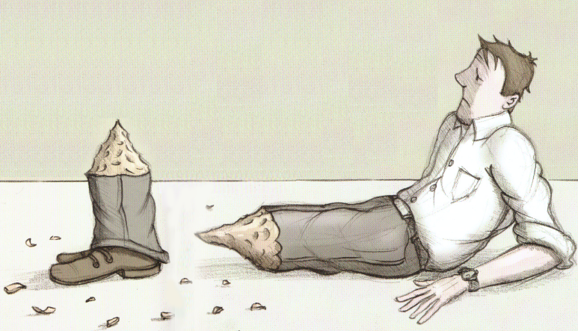

Against C is for Criticism is this image of a man chopped off at the knees, hurt by other people’s criticisms of him and by his own criticisms of other people. The text next to it says: ‘Criticism tells you everything you need to know about yourself so listen carefully. The faults you point out in others are very often your own in disguise’. And then its parting shot is: ‘criticism is a form of self-harm. Go easy.’
It struck me how accurately this reflects today’s reading: ‘Criticism tells you everything you need to know about yourself’ corresponds to that speck you spot in someone else’s eye may well be the plank in your own. ‘Criticism is a form of self-harm’ corresponds to ‘do not condemn and you will not be condemned’.
Only Jesus wants us to take it further than this book, he wants us to see the bigger picture, not be so concerned with the minor details and misdemeanours - the speck in someone else’s eye - that we fail to see our own plank, missing the fact that he came so we can be in relationship with God, that we are to be changed from within, changing this world as we live out his love. So that we will not be the blind leading the blind.

The undeniable reality though is that this ‘not judging’, this ‘oneness’ business is a phenomenal challenge in our culture of rampant individualism.
Franciscan priest and author Richard Rohr says: ‘If we’re honest, culture forms us much more than the Gospel. It seems we have kept the basic storyline of human history in place rather than allow the Gospel to reframe and redirect the story. Except for those who have experienced grace at their core, Christianity has not created “a new mind” (Romans 12:2) or a “new self” (Ephesians 4:23-24) that is significantly different than the cultures it inhabits. The tired, old win/lose scenario seems to be in our cultural hard drive, whereas the experience of grace at the core of reality, which is much more imaginative and installs new win/win programs in our psyche, has been neglected and unrecognised by most of Christianity.’

Other cultures undoubtedly recognise the value of mutual flourishing more than our own. in South Africa ‘Ubuntu’ is a philosophy of the recognition that we are all bound together in ways that are invisible to the eye; that there is a oneness to humanity; that we achieve ourselves by sharing ourselves with others and caring for those around us. It was a basis for the post-Apartheid Truth and Reconciliation Commission
Desmond Tutu sees Ubuntu through the lens of his Christian faith and says: ‘All of our humanity is dependent upon recognizing the humanity in others. A person with ubuntu is open and available to others, affirming of others, does not feel threatened that others are able and good, for he or she has a proper self-assurance that comes from knowing that he or she belongs in a greater whole and is diminished when others are humiliated or diminished.”

And whether the wider world wants to acknowledge it or not churches in the UK have traditionally felt a connection with brothers and sisters near and far, have been hurt by the pain of others and have been moved to act to defend their dignity and address their suffering. Christian Aid was established after WWII when churches in the UK responded to the plight of refugees right across Europe.

On Wednesday it was a joy to welcome aid worker Joanna and hear her talk about the impact of Christian Aid’s work helping communities build health clinics in rural areas in her home country of Sierra Leone. There is one nurse or midwife to 10,000 people in Sierra Leone, which is still struggling to recover from the devastating outbreak of Ebola which ended three years ago and the civil war before that.

This slide is of Nurse Judith who received extra training from a Christian Aid partner, checking on the health of heavily pregnant Jebbeh. Jebbeh’s sister Fatmata had recently died in childbirth, tragically by the side of the road as she attempted to walk to get medical help. Joanna’s visit enabled us to see the life-saving effects of the money which this church so generously gives and we were able to glimpse that sense of covenant and oneness– we give the money without conditions, we give out of love for those who are suffering, even though we will never know them, we pray because their pain on one level is our pain too.

I love reading Luke, we have the huge sweep of God’s plan told through very human stories of a young girl pregnant, of worshippers who switch from eager listeners to enraged mob, men who love their paralysed friend so much they lower him through a roof to get to Jesus. We see God breaking into ordinary lives. But change creates fear and we have to work out our response to that. One of the quotes from the past year that has stayed with me is from the then 15 year-old climate change activist Greta Thunberg who said: “we seem to be more afraid of the changes needed to prevent catastrophic climate change than of catastrophic climate change itself.” Is our fear of change, of walking a different way, bigger and stronger than our desire to be co-creators with God of the better world he wants to see?
Thankfully we have a merciful God, a God of compassion who knows that as hard as we try, we will always remain human, flawed, frail, limited. He doesn’t expect anything else.
But our choice now, just as it was for those listening on the mount, is can we walk the way of Jesus and do whatever it takes to make the world whole, to not divide into winners and losers but seek the flourishing of all people, even, perhaps especially when, that is difficult?

Can we find the courage to surrender to God and allow him to change our human story, so that when a destitute woman or the parents of an autistic child need help, they know that instead of judgement or despair when they turn to Christians and the church they will find sanctuary, hope and love.

